Riphah International University
Gulberg Green Campus Islamabad
Faculty of Computing (WISH)



Name: Anisha Rehmat.
Sap ID: 78019.
Submitted To: Mam Nayab Khalid
Submitted by: Anisha Rehmat.

Supervision and Coordination

Miss Hira Jafar
Lecturer
Faculty of Computing

Lab Designers

Miss Nayab Khalid
Teaching Fellow
Faculty of Computing

Lab Task 8

Learning Outcomes:
        - Grasp the concept of "one name, many forms" and its practical use cases.
- Compare compile-time (static) overloading with runtime (dynamic) overriding.
- Write multiple methods with identical names but distinct parameters within a single class.
- Use inheritance to let subclasses redefine inherited methods with @Override.
- Call subclass implementations at runtime using superclass reference variables.

Lab Tasks

Task 1: Hospital Appointments.
At City Care Hospital, patients book appointments in three ways: by name only (a general doctor, today), by name and doctor (today), or by name, doctor and day number. Create a class Hospital and overload the book() method three times to handle these cases. Each version should print a confirmation message. Test all three versions in main().

Code:-
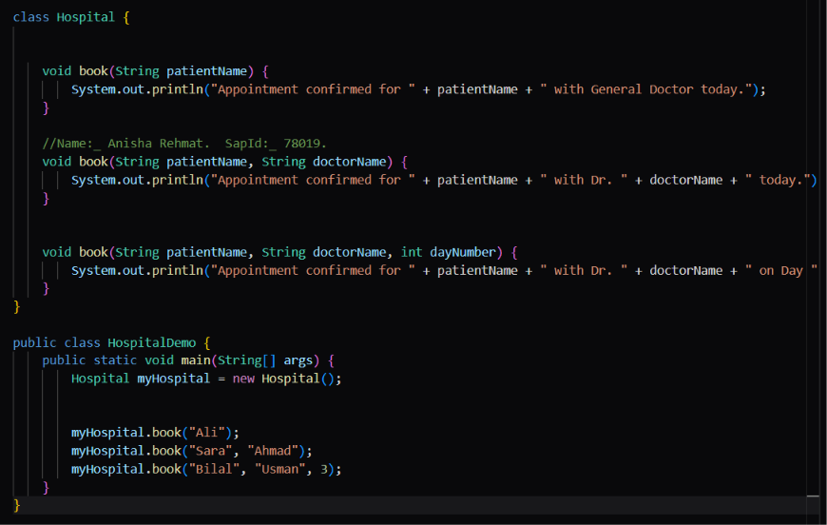
Output:_
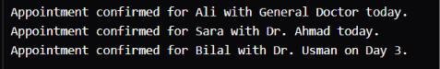

Task 2: Ride Fare Calculator
A ride app charges a different rate per kilometre for each vehicle. Create a base class Ride with a method calculateFare(int km) that charges 25 per km. Then create subclasses Bike (20 per km), Car (40 per km) and Rickshaw (30 per km), each overriding the method and returning the fare as a double. In main(), store all three in a Ride[] array, loop through it, and print each fare for 10 km.
Code:-

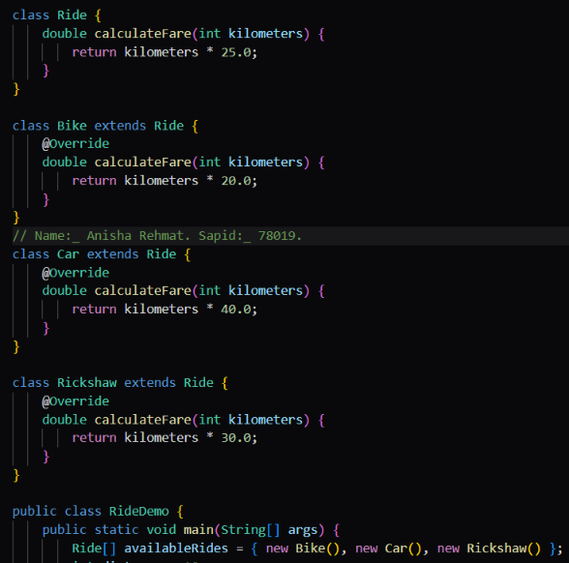
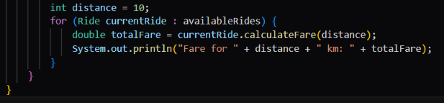
Output:_
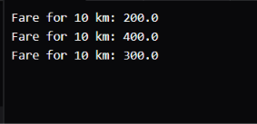

Task 3: University Fee with Scholarship
A university calculates student fees with or without a custom discount percentage. Create a class Fee with two overloaded methods: calculate(double tuition) returns the tuition unchanged, and calculate(double tuition, double percent) returns the tuition minus that percentage. Scholarship students get 20% off by default, so create a subclass ScholarshipFee that overrides only the one-parameter method. In main(), use a tuition of 50000 and test both classes with both methods.
Code:_

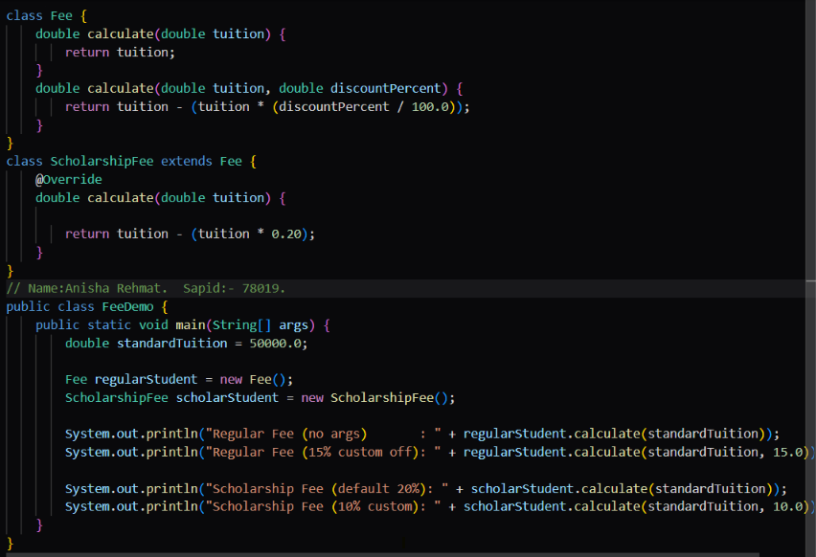
Output:-


